Kathryn Lucille (Reef) Summers
October 6, 1929 – July 27, 1992

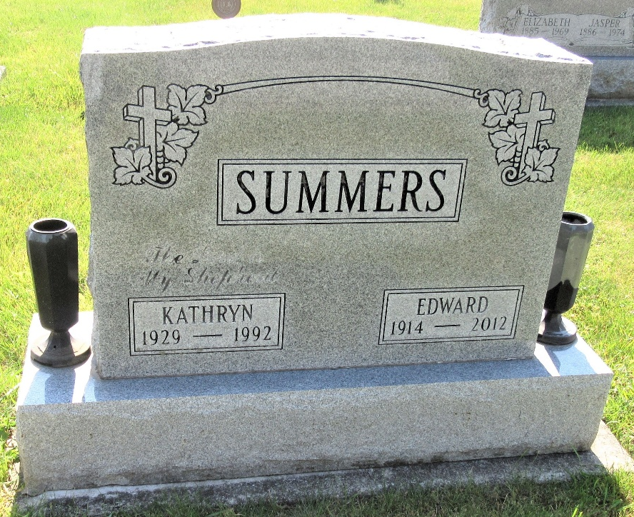
Photo by PLS

KATHRYN L. SUMMERS, 62, of Decatur died yesterday in Adams County Memorial Hospital. The Hagerstown, Md., native was a secretary for the Adams County Welfare Department for 14 1/2 years.
Surviving are her husband, Edward; a daughter, Judy Knapp of Monmouth, Ore.; a son, Kermit of Decatur; a sister, Phyllis Rayer of Decatur; brothers, Lloyd "Bud" Reef and Ralph "Toby" Reef, both of Decatur; and two grandchildren.
Services are 2 p.m. tomorrow in Zwick-Sefton & Jahn Funeral Home, Decatur, where calling is 2 to 9 p.m. today, and 12:30 to 2 p.m. tomorrow. Burial will be in Decatur Cemetery.
Preferred memorials are gifts to the Decatur Missionary Church.

News-Sentinel, The (Allen County, Indiana)
Tuesday, July 28, 1992

**
Indiana, U.S., Death Certificates, 1899-2017

Name Kathryn L Summers
[Kathryn L Reef]
Gender Female
Race White
Marital Status Married
Age 62
Birth Date 6 Oct 1929
Birth Place Jefferson Township
Death Date 27 Jul 1992
Death Place Decatur, Adams, Indiana, USA
Death Registration Date 1992
Father Adam Reef
Mother Ruth Butcher
Spouse Edward Summers
Informant Edward Summers; husband; Decatur, Indiana
Burial July 29, 1992; Decatur Cemetery; Decatur, Indiana

