Felix C. Summers
August 17, 1854 – August 5, 1922

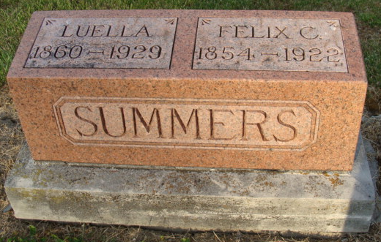
Photo by Alicia Kneuss

PNEUMONIA WAS CAUSE OF DEATH
F. C. Summers, Well-known Drayman, Died at Home Here Saturday

F. C. Summers, age 67 years, one of the familiar and well-liked characters of this city, died at his home at 310 North Eleventh Street, at 10 o'clock Saturday night, following an illness of eleven days duration, with pneumonia. Mr. Summers was born in Van Wert, Ohio, on August 17, 1854, but has spent much of his life in this city and community. For several years he has been a drayman in this city, and through this occupation became well-known by the citizens of Decatur. He was much respected and he will be greatly missed. Mr. Summers is survived by his wife. Funeral services will be held from the Baptist Church at 2 o'clock Tuesday afternoon, the Rev. F. D. Whitesell, pastor of the Baptist Church officiating. Burial will be held in the Decatur Cemetery.

Decatur Daily Democrat, Adams County, Indiana
Monday, August 7, 1922
**

Felix Caslin Summers was born in Van Wert County, Ohio,
Aug. 17, 1854, and died at his home in Decatur, Indiana, Aug.
5, 1922, aged 67 years, 11 months and 18 days. In early
manhood he was united in marriage to Miss Luella Shepherd,
who survives him.
He engaged in farming in Adams County until about
fourteen years ago. When upon moving to Decatur, he
entered the draying business. He was a faithful member of
the Decatur Baptist Church, a respected citizen and a sincere
neighbor.
Besides the widow, there survives one sister, Mrs. Aaron
Stevens, Decatur; two half-sisters, Mrs. L. B. Okeley, Pleasant
Mills, and Mrs. Ora May, Ft. Wayne; one half-brother, Mr.
Omar Clay, Columbia City, and many other relatives and
friends. His friendly smile and cheery greeting will be missed by all
who knew him.

Card of Thanks: In this manner we desire to thank all those
who so kindly assisted us during the illness and death of our
beloved husband and brother. We surely appreciate the help
given by the neighbors, the beautiful floral of the neighbors,
the beautiful floral offerings, the kindness of Rev. Mines and
Rev. Whitesell, and the beautiful singing of the Baptist Choir.​

Decatur Daily Democrat, Adams County, Indiana
Friday, August 11, 1922

**
Indiana, U.S., Death Certificates, 1899-2017

Name F. C. Summers
Gender Male
Race White
Marital Status Married
Age 67
Birth Date 17 Aug 1854
Birth Place Van Wert Ohio
Death Date 5 Aug 1922
Death Place Decatur, Adams, Indiana, USA
Death Registration Date 1922
Father Henry Summers
Mother Sarrah Harvey
Spouse Sarrah L.
Informant Mrs. F. C. Summers; Decatur, Indiana
Burial August 8, 1922; Decatur Cemetery

