Edward Louis Summers
June 20, 1914 – July 8, 2012

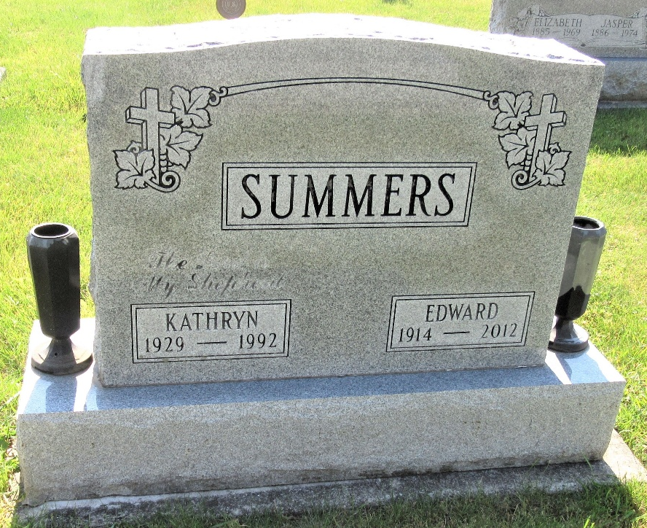
Photo by PLS

Edward L. Summers, 98, Decatur, passed away Sunday, July 8, 2012 at 1 p.m. at his residence. Mr. Summers served in the Civilian Conservation Corps during the Great Depression and helped construct the Ouabache State Park.
Born in Decatur on June 20, 1914 to Lloyd E. and Rose E. (Hoffman) Summers, he married Kathryn L. Reef on Aug. 4, 1948; she died July 27, 1992.
He retired from Howard Sober in 1976 after 35 years of service. He was a member of the Cornerstone Community Church (formerly Decatur Missionary Church) in Decatur, the Adams County Historical Society, the Adams County Amateur Radio Club, the National Rifle Association, Adams County Coin Club, and was previously a Boy Scout Master for Troop 63.
Survivors include a son, Kermit Summers of Decatur; a daughter, Judy (John) Knaupp of Rickreall, Ore.; a brother, R. Thomas Summers of Fort Wayne; a sister, Evelyn (Allen) Felt of Hoagland; two grandsons, John (Angela) Summers and Phillip (Alissa) Summers; four great-grandchildren, Katie Summers, Luke Summers, Corbin Summers, and Cameron Summers.
He was preceded in death by two brothers, Walter and James Summers; and three sisters, Mary Johnson, Martha Morris, and Dorothy Lunn.
Services will be held Thursday at 10 a.m. in the Zwick and Jahn Funeral Home in Decatur with Rev. Ken Hogg officiating. Calling hours there will be Wednesday from 2 to 5 and 6 to 8 p.m. Burial will be in the Decatur Cemetery. Preferred memorials are to the Cornerstone Community Church.

Bluffton News-Banner, The (Wells County, Indiana)
Monday, July 9, 2012
**

Indiana, U.S., Death Certificates, 1899-2017

Name Edward L Summers
Gender Male
Race White
Age 96
Birth Date 20 June 1914
Birth Place Decatur, Indiana
Death Date 8 Jul 2012
Death Place Decatur, Adams, Indiana, USA
Death Registration Date 2012
Father Lloyd E. Summers
Mother Rose E. Hoffman
Informant Kermit Summers; son; Decatur, Indiana
Burial Decatur Cemetery; Decatur, Indiana
Certificate Number 030487

