Wilbur H. Suman
February 7, 1901 – May 6, 1961

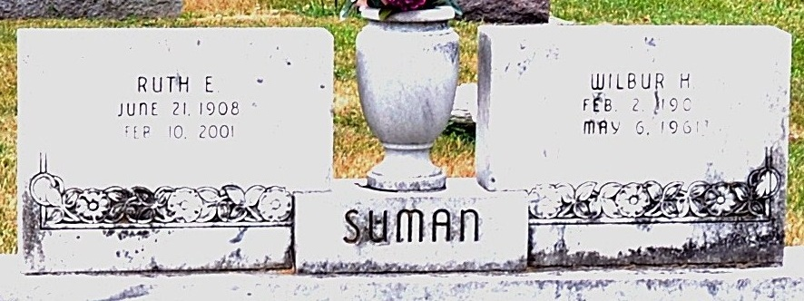
Photo by PLS

Wilbur Suman Dies Early This Morning
Wilbur H. Suman, 60, veteran G.E. employee, died suddenly at 5:30 o'clock this morning at his home in Monmouth. Although he had been ill for several years, his death was unexpected. He was born at Portland Feb. 7, 1901, a son of Dawson and Louise Loshe-Suman, and was married to Ruth E. Burger Oct. 2, 1929.
Mr. Suman had been employed at the Decatur plant of the General Electric Co. for the past 32 years.
Surviving in addition to his wife are three daughters, Mrs. Richard (Bonnie) Rumschlag of Decatur, Mrs. Dave (Louise) Stanford of Bourbonnais, Ill., and Miss Kaye Suman, at home; three grandchildren, and three sisters, Mrs. Harry Crownover of Decatur, Mrs. Damon Case of Willshire, O., and Mrs. Melvin Ehrsam of Tucson, Ariz. One brother and three sisters are deceased.
Funeral services will be conducted at 1:30 p.m. Tuesday at the Black Funeral Home and at 2 p.m. at the Church of the Nazarene, the Rev. C. E. Lykins officiating. Burial will be in the Decatur Cemetery. Friends may call at the funeral home after 2 p.m. Sunday until time of the services.
Adams County Historical Museum, Adams County, Indiana
January 1951 – August 1962 Scrapbook, image 22
Handwritten date: Saturday, May 6, 1961
**

Indiana, U.S., WPA Birth Index, 1880-1920
Name: Suman
Father: Dawson
Mother: Louisa Lord [sic]
County: Jay
Gender: Male
Birth Date: Feb 7, 1901
Reference: Jay County, Indiana<BR>Index to Birth Records<BR>1882 - 1920 Inclusive<BR>Volume I<BR>Letters A - Z Inclusive
Book: CH-1
Page: 16
**

Indiana, U.S., Death Certificates, 1899-2011
Name: Wilbur H Suman
Gender: Male
Race: White
Age: 60
Marital status: Married
Birth Date: 7 Feb 1901
Birth Place: Jay County, Ind
Death Date: 6 May 1961
Death Place: Monmouth, Adams, Indiana, USA
Father: Dawson Suman
Mother: Louise Loshe
Informant: Mrs. Wilbur Suman; wife; Monmouth, Indiana
Burial: May 9, 1961; Maplewood Cemetery; Decatur, Indiana
**

U.S., World War II Draft Cards Young Men, 1940-1947
Name: Wilbur Herbert Suman
Gender: Male
Race: White
Age: 41
Relationship to Draftee: Self (Head)
Birth Date: 7 Feb 1901
Birth Place: Portland, Indiana
Residence Place: Decatur, Adams, Indiana, USA
Registration Date: 16 Feb 1942
Registration Place: Indiana, USA
Employer: General Electric Company
Height: 5 11; Weight: 160
Complexion: Light
Hair Color: Brown; Eye Color: Gray
Next of Kin: Ruth Edith Suman

