Ruth E. (Burger) Suman
June 21, 1908 – February 10, 2000

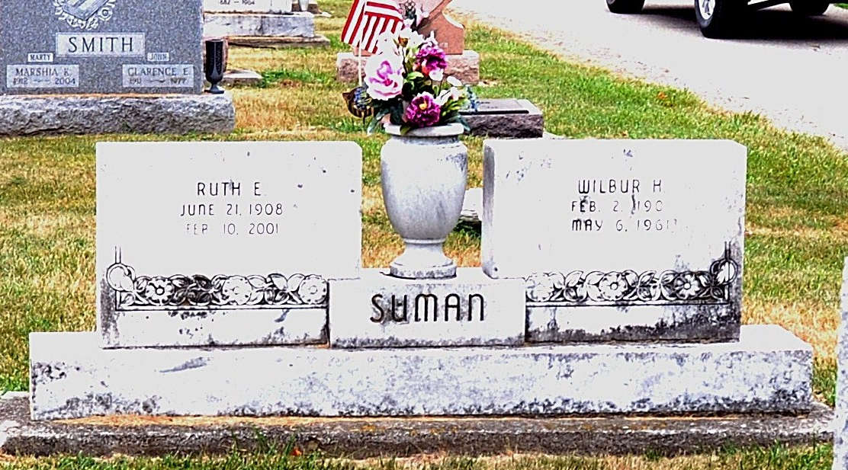
Photo by Deb Curry

Ruth E. Suman, 92, of Decatur, a homemaker who taught Sunday school for many years, died Saturday, Feb. 10, 2001, at Adams County Memorial Hospital, Decatur. The Adams County native was a member of Decatur Church of the Nazarene.
Surviving are her daughters, Bonnie Rumschlag and Kaye A. Huss, both of Decatur, and Lois B. Stanford of Dayton, Ohio; a brother, Robert Burger of Decatur; sisters Mary Shifferly of Berne, Rosa Fox and Anna Fleming, both of Decatur, and Lucretia Minnich of Linn Grove; 12 grandchildren; 25 great-grandchildren; and two great-great-grandchildren.
She was preceded in death by her husband, Wilbur H.; six brothers; and six sisters.
Services are 2 p.m. Tuesday at Decatur Church of the Nazarene, with calling one hour before services. Calling will also be held from 2 to 4 and 6 to 8 p.m. today at Haggard & Sefton Funeral Home, Decatur. Burial will be at Decatur Cemetery. Memorials are to the church or the Adams County Cancer Society. Information provided by Haggard and Sefton Funeral Home, Decatur, 1-219-724-7167.

News-Sentinel, The (Allen County, Indiana)
Monday, February 12, 2001
**

Indiana, U.S., Death Certificates, 1899-2017

Name Ruth E Suman
[Ruth E Burger]
Gender Female
Race White
Marital Status Widowed
Age 92
Birth Date 21 Jun 1908
Birth Place Indiana
Death Date 10 Feb 2001
Death Place Decatur, Adams, Indiana, USA
Death Registration Date 2001
Father Alva K Burger
Mother Edna Harden
Informant Mrs. Bonnie Rumschlag; daughter; Decatur, Indiana
Burial February 13, 2001; Decatur Cemetery; Decatur, Indiana

