Irene Elizabeth (Hoffman) Suman
March 24, 1915 – December 20, 1984

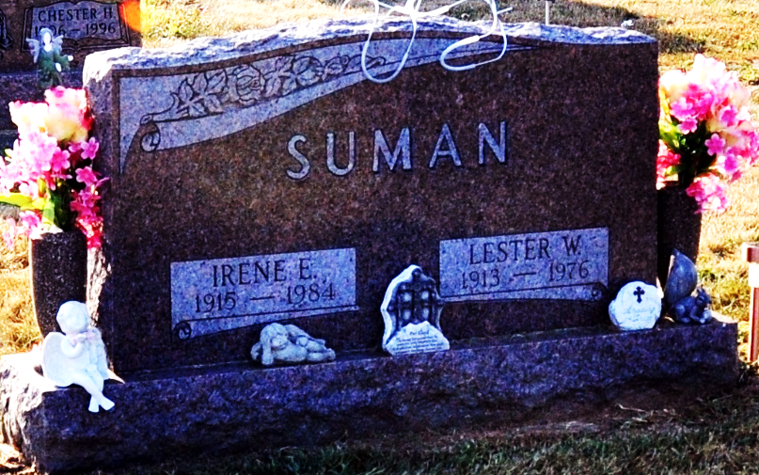
Photo by Deb Curry

Irene E. Suman
in the Indiana, U.S., Death Certificates, 1899-2017

Name Irene E. Suman
[Irene E. Hoffman]
Gender Female
Race White
Age 69
Marital Status Widowed
Birth Date 24 Mar 1915
Birth Place Indiana
Death Date 20 Dec 1984
Death Place Bluffton, Wells, Indiana, USA
Death Registration Date 1984
Father: Jacob Hoffman
Mother: Lucinda Wagner
Informant: Julia Ann Stetler; daughter; Wren, Ohio
Burial: December 23, 1984; Decatur Cemetery; Decatur, Indiana

