Drusilla S. (Brown) Suman
November 21, 1865 – January 26, 1964

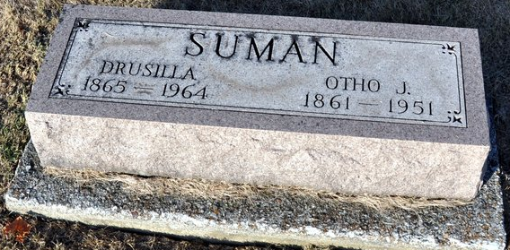
Photo by Deb Curry

Drusilla S Suman
in the Indiana, Death Certificates, 1899-2011
Name: Drusilla S Suman
[Drusilla S Brown]
Gender: Female
Race: White
Age: 98
Marital status: Widowed
Birth Date: 21 Nov 1865
Birth Place: Ohio
Death Date: 26 Jan 1964
Death Place: Ft Wayne, Allen, Indiana , USA
Father: Lorenzo Brown
Mother: Phoebe Hayworth
Informant: Mrs. Ora Brown; sister-in-law; Fort Wayne, Indiana
Burial: January 29, 1964; Maplewood Cemetery; Decatur, Indiana

