Clara Mae “Sally” Suman
May 3, 1919 – September 17, 1969

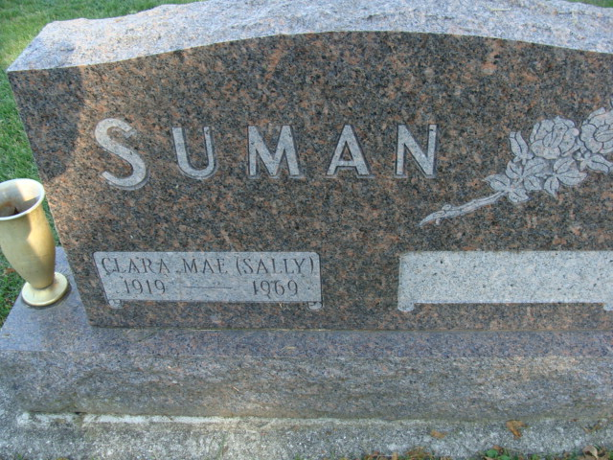
Photo by Alicia Kneuss

County native dies today

Mrs. Sally Diehl Suman, 50, a native of Adams County, was dead on arrival at the Lutheran Hospital at 8:30 a.m. this morning. Death was sudden and unexpected.
Mrs. Suman, a resident at 3516 S. Park Drive, Fort Wayne, was an employee of the x-ray department at Lutheran Hospital.
The daughter of Ervin and Vera Tarr Diehl, she was born May 3, 1919 in Adams County. Her father survives in San Francisco, Calif.
On August 29, 1937, she was married to Otho U. Suman, who also survives. Their children are: Mrs. Walter (Dorcus) VanDine, Detroit, Mich.; Glen Thomas Suman, Fort Wayne; Michael D. Suman, a student at Pasadena Nazarene College, Pasadena, Calif.; also, a sister, Mrs. Kenneth Leopold, Concord, Calif.; and two brothers, William Diehl, Martinsville, Va., and Brice Diehl, Angola; and three grandchildren.
Mrs. Suman attended the Fairfield Church of the Nazarene, Fort Wayne.
Friends may call at the Zwick Funeral Home after 7 p.m. tonight. The funeral will be at 1:30 p.m. Friday at the Zwick Funeral Home, the Rev. Ronald Bishop officiating.

Decatur Daily Democrat, Adams County, Indiana
Wednesday, Sept.17, 196

