Charles E. Sullivan
July 9, 1875 – September 24, 1945

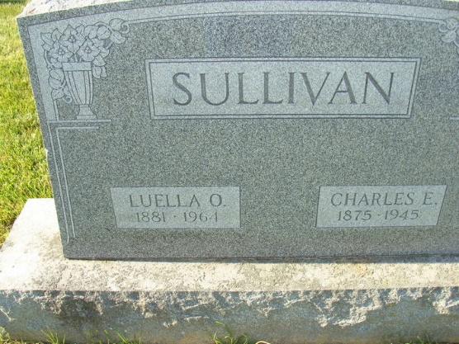
Photo by Alicia Kneuss

Charles E. Sullivan Dies This Morning
Funeral Services Here On Wednesday

Charles E. Sullivan, 70, a retired salesman, died at 9:15 o'clock this morning at his home, 122 North Tenth Street. Death was caused by a cerebral hemorrhage. He had been ailing for the past three years and bedfast for three weeks. He was born in Mansfield, O., July 9, 1875, the son of John and Julia Pixler Sullivan, but had resided in Adams County for practically his entire life.
He was a member of the Union U. B. Church.
Surviving are the wife, formerly Luella O. Crabill; one daughter, Mrs. Gail Dunifon of Fort Wayne; one foster sister, Mrs. Alice Bier of Indianapolis; a granddaughter, Mrs. Ellen Stults of Decatur; two grandsons, T/Sgt. Jack Dunifon, in India, and Eugene Dunifon of Fort Wayne, and one great-grand-daughter, Beverly Kay Stults of Decatur. Four brothers are deceased.
Funeral services will be held at 2:30 p. m. Wednesday at the Zwlck Funeral Home, with the Rev. J. T. Trueax of the Church of the Nazarene officiating. Burial will be in the Decatur Cemetery. Friends may call at the funeral home after 2 p. m. Tuesday.

Decatur Daily Democrat; Adams County, Indiana
Monday, September 24, 1945
**

COURT HOUSE - Will Is Probated

The will of the late Charles E Sullivan was admitted to probate. The document was written Oct. 13. 1915. The estate, both real and personal, was bequeathed to the widow, Luella O. Sullivan.

Decatur Daily Democrat, Adams County, Indiana
October 8, 1945

