Walter F. Sudduth
March 27, 1887 – June 23, 1978

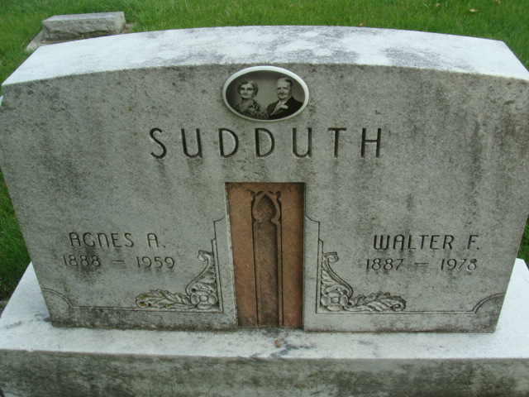
Photo by Alicia Kneuss

Walter F Sudduth
in the Indiana, U.S., Death Certificates, 1899-2017

Name Walter F Sudduth
Gender Male
Race White
Marital Status Married
Age 91
Birth Date 27 Mar 1887
Birth Place Indiana
Death Date 23 Jun 1978
Death Place Decatur, Adams, Indiana, USA
Death Registration Date 1978
Father Harrison Sudduth
Mother Hannah Nickols
Spouse Donnabelle Morris Delanter?
Informant Mrs. Walter F. Sudduth; Decatur, Indiana
Burial June 26, 1978; Decatur Cemetery; Decatur, Indiana

