Vera E. (Hawkins) Sudduth
June 8, 1915 – February 24, 2010

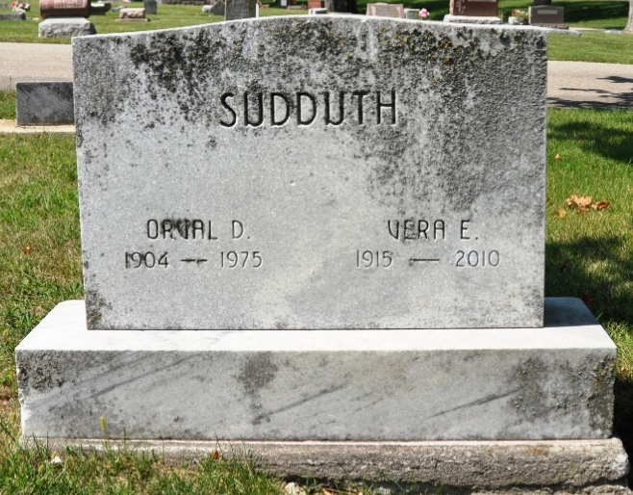
Photo by Deb Curry

Vera E. Sudduth, 94, of Decatur, IN passed away at 10:10 a.m. on Wednesday, February 24, 2010 at Woodcrest Nursing Center. She was born on June 8, 1915 in Adams County, IN to Leroy and Mable (Sprague) Hawkins. She was married to Orval Sudduth; he passed away on January 15, 1975.
She is survived by 2 daughters Mrs. Gary (Jewel A.) Shoaf of Decatur, IN and Mrs. Tom (Sharon K.) Suman of Monroe, IN; a granddaughter Mrs. Rob (Mindy) Knefelkamp of Decatur, IN (whom she raised); 5 grandchildren and 6 great grandchildren and 2 sisters Mazetta Metcalfe of Monroe, IN; and Mrs. Amos (Mary Alice) Bauman of Fort Wayne, IN.
She was preceded in death by her husband, a son Thurman Sudduth, 5 brothers, and a sister.
Vera was a charter member of the former Decatur Church of the Nazarene. She babysat for many local families and was the custodian for the Decatur Church of the Nazarene.
Visitation will be from 11:00 a.m. - 4:00 p.m. on Sunday, February, 28, 2010 at Haggard & Sefton Funeral Home. Funeral Service will be held at 10:00 a.m. on Monday, March 1, 2010 at Grace Fellowship Church (formerly Decatur Church of the Nazarene). Officiating will be Pastor Dan York and burial will take place in Decatur Cemetery. Memorials may be made to Family Hospice & Palative Care or Nazarene Memorial Roll.

Haggard & Sefton Funeral Home, Adams County, Indiana
March 1, 2010

