Thurman D. Sudduth
March 26, 1935 – December 1, 2000

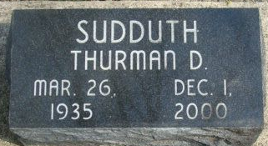
Photo by Alicia Kneuss

Thurman D. Sudduth, 65, of Decatur, a member of First Church of the Nazarene, died Friday, Dec. 1, 2000, at Select Specialty Hospital, Fort Wayne. The Allen County native was a custodian for the church for 25 years.
Surviving are his mother, Vera E. of Decatur; sisters Jewel Shoaf of Decatur and Sharon Suman of Loveland, Colo.; a niece, Mindy Knefelkamp of Decatur; and several other nieces and nephews.
Services are 2 p.m. Tuesday at First Church of the Nazarene, Decatur, with calling one hour before services. Calling will also be held from 2 to 4 and 6 to 8 p.m. today at Haggard & Sefton Funeral Home, Decatur. Burial will be at Decatur Cemetery.
Memorials are to the church.

News-Sentinel, Allen County, Indiana
Monday, December 4, 2000

