Ted J. Sudduth
September 26, 1894 – December 13, 1960

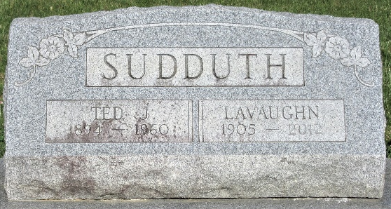
Photo by PLS

Ted Sudduth Dies Here Last Evening

Ted Sudduth, 66, of 1110 Elm Street, lifelong resident of Adams County, died at 8 p.m. Tuesday at the Adams County Memorial Hospital. Death was attributed to complications. He had been seriously ill for the past three weeks.
He was born in Adams County Sept. 26, 1894, a son of Elias and Sarah Gilbert-Sudduth, and was married to Lavone Stetzel June 16, 1922. Mr. Sudduth was a member of the Church of the Nazarene.
Surviving in addition to his wife are his mother; two sons, Frederick and Robert Sudduth, both of Decatur; one daughter, Mrs. Richard (Joyce) Steiner of Linn Grove; eight grandchildren; one great-grandchild; two brothers, Aaron and Harrison Sudduth, both of Decatur, and one sister, Mrs. Jesse Plasterer of Decatur. One brother and one grandchild preceded him in death.
Funeral services will be conducted at 1:30 p.m. Friday at the Black Funeral Home and at 2 p.m. at the Church of the Nazarene. The Rev. C.E. Lykins and the Rev. J.O. Penrod will officiate, and burial will be in the Decatur Cemetery. Friends may call at the funeral home after 7 p.m. today until time of the services.

Adams County Historical Museum, Adams County, Indiana
January 1958 – December 1960, image 59
Handwritten date: Wednesday, December 14, 1960

