Sarah C. (Gilbert) Sudduth
December 27, 1876 – March 7, 1965

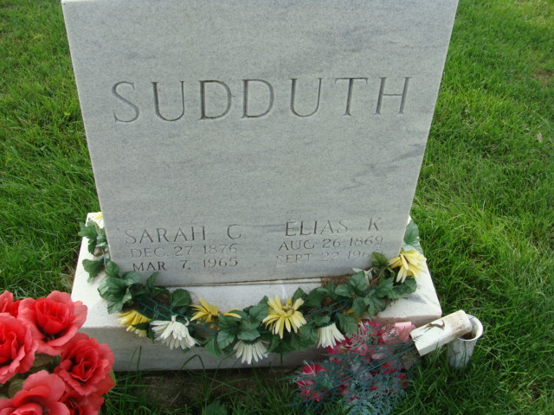
Photo by Alicia Kneuss

Indiana, U.S., Death Certificates, 1899-2017

Name Sarah C Sudduth
[Sarah C Gilbert]
Gender Female
Race Caucasian (White)
Marital Status Widowed
Age 88
Birth Date 27 Dec 1876
Death Date 7 Mar 1965
Death Place Decatur, Adams, Indiana, USA
Death Registration Date 1965
Father Jasper Gilbert
Mother Philemon Stogdill
Informant Mrs. Jesse Plasterer; daughter; Decatur, Indiana
Burial March 10, 1965; Decatur Cemetery; Decatur, Indiana
**

Adams County (IN) Public Library online obit abstracts

Title: Sudduth, Sarah
Publication: Decatur Daily Democrat; Date: 08 MAR 1965
Subjects: Obituaries -- S -- 1960-1969
Abstract: Age: 88; Died: March 7, 1965 - Adams County Hospital ; Born: December 27, 1876 - Kirkland Township ; Daughter of: Jasper & Philemon Stogdill Gilbert; Married: Elias Sudduth - November 11, 1893; he died September 22, 1960; Burial: Decatur Cemetery ; Member of: Trinity E.U.B. Church , Decatur

