Ruth (Hamrick) Sudduth
September 22, 1923 – September 14, 2016

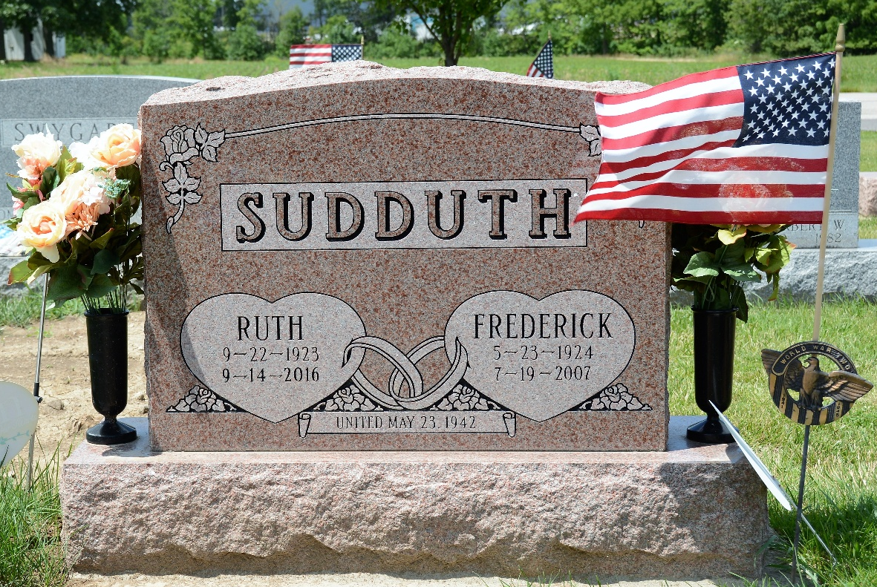
Photo by Deb Curry

Ruth (Hamrick) Sudduth, 92, of Decatur, IN, passed away on Wednesday, September 14, 2016 at Adams Woodcrest. She was born on September 22, 1923, in Adams County, IN, to the late Calvin H. and Fausta I. (Skidmore) Hamrick. On May 23, 1942, she married Frederick J. Sudduth and after 65 years together, he preceded her in death on July 19, 2007.
She was a 1941 graduate of Monroe High School and worked as a lifelong homemaker. She was a member of the former First Church of the Nazarene. Ruth and Fred enjoyed the many good times with the Good Sam Camping Club.
Ruth is survived by 2 sons, Gerald D. (Geraldine) Sudduth and Dennis J. (Tonya) Sudduth both of Decatur; 3 daughters, Carolyn L. (Ray) Roman, Linda L. Anderson, and Teresa A. (Randall) Sipe all of Decatur; 1 sister, Charlene Dailey of Decatur; 25 grandchildren, 35 great grandchildren and 32 great-great grandchildren. She was preceded in death by a son-in-law, John Anderson and 3 sisters.
Visitation will be from 12:00 – 4:00 p.m. on Sunday, September 18, 2016 at Haggard-Sefton & Hirschy Funeral Home. A Funeral Service will be held at 10:30 a.m. Monday, September 19, 2016 at Haggard-Sefton & Hirschy Funeral Home, with calling 1 hour prior from 9:30 – 10:30 a.m. Pastor Dan Aguilar will be officiating and burial will take place in the Decatur Cemetery.
Memorials may be made to Family Life Care.

Haggard-Sefton Funeral Home, Adams County, Indiana

