Phyllis Jane Sudduth
June 7, 1937 – October 15, 1937

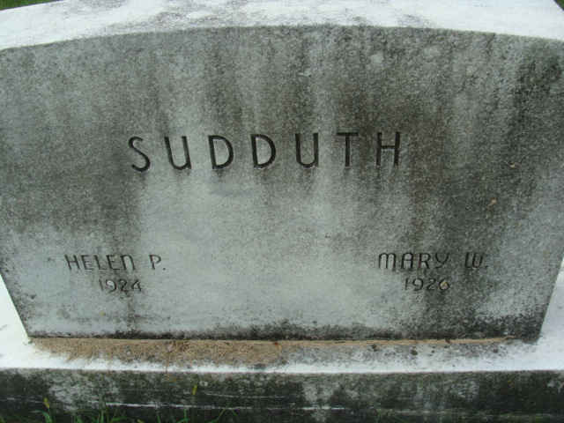
Photo by Alicia Kneuss

Phylis Jane Suddith
in the Indiana, U.S., Death Certificates, 1899-2017

Name Phylis Jane Suddith
Gender Female
Race White
Marital Status Single
Age 4 months, 8 days
Birth Date 7 Jun 1937
Birth Place Decatur, Indiana
Death Date 15 Oct 1937; accidental strangulation
Death Place Decatur, Adams, Indiana, USA
Death Registration Date 1937
Father Harvey Suddith
Mother Marsella Gilbert
Informant Mrs. Harvey Suddith; Decatur, Indiana
Burial October 17, 1937; Decatur Cemetery

