Mary Waverlene Sudduth
August 22, 1926 – August 22, 1926

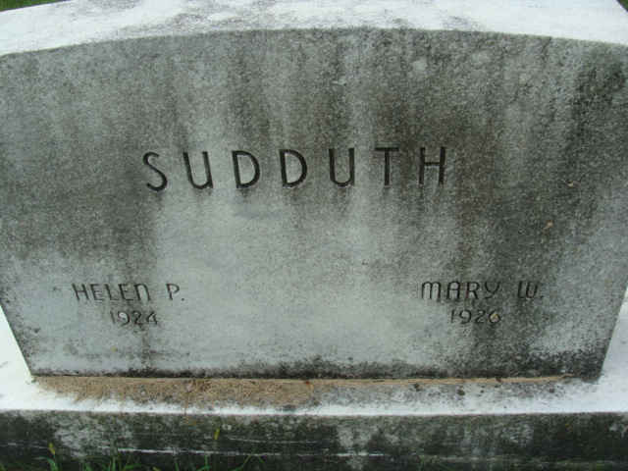
Photo by Alicia Kneuss

Mary Waverlene Sudduth
in the Indiana, U.S., Birth Certificates, 1907-1944

Name Mary Waverlene Sudduth; born alive
Gender Female
Birth Date 22 Aug 1926
Birth Place Decatur, Adams, Indiana, USA
Father Walter Sudduth; age 39
Mother Agnes Odle; age 38; 4th child, 2 living
Certificate Number 37904
Roll number 40474_357814
Volume Range 76 - 80
**

Indiana, U.S., Death Certificates, 1899-2017

Name Mary Wavalene Sudduth
Gender Female
Race White
Age 5 hours
Birth Date 22 Aug 1926
Birth Place Indiana
Death Date 22 Aug 1926
Death Place Washington, Adams, Indiana, USA
Death Registration Date 1926-1927
Father Walter Sudduth
Mother Agness Odle
Informant Walter Sudduth
Burial August 24, 1926; Decatur Cemetery

