Beatrice Lavaughn (Stetzel) Sudduth-Johnson
April 16, 1905 – September 10, 2012

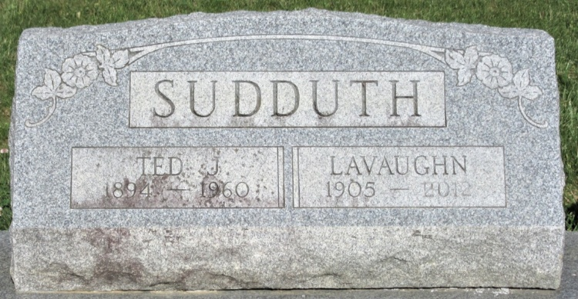
Photo of PLS

Beatrice Lavaughn Johnson, 107, of Decatur died Monday, September 10, 2012 at Woodcrest Nursing Center. She was born April 16, 1905 in Adams County to the late Harvey and Cora (Lee) Stetzel. She married her first husband Teddy J. Sudduth and he died December, 1960; then married Lester Johnson, he died August, 1980.
Lavaughn was a member of the former Decatur Nazarene Church. She was a homemaker.
Survivors are a son Robert L. & wife (Hillis) Sudduth of Angola, IN; a step son Ron Johnson of Decatur; a daughter Mrs. Richard (Joyce) Steiner of Linn Grove; a step daughter Mrs. Jim (Barbara) Jarshaw of California; a daughter-in-law Ruth Sudduth; 12 grandchildren, 39 great grandchildren, 60 great-great grandchildren and 8 great-great-great grandchildren. She was preceded in death by a son Fred Sudduth, 8 sisters, 2 brothers, 1 grandson and 1 granddaughter.
Calling is from 2:00-4:00 and 5:00-7:00 p.m. Thursday, September 13, 2012 at Haggard-Sefton & Hirschy Funeral Home. Funeral service will be Friday, Sept. 14th at 10:00 a.m. also at the funeral home. Chaplain Chris Thurow will be officiating and burial will be in Decatur Cemetery.
Memorials are to Family Life Care-Hospice.

Haggard-Sefton & Hirschy Funeral Home, Adams County, Indiana
September 11, 2012

