Jerry Allen Sudduth
May 12, 1953 – October 18, 1953

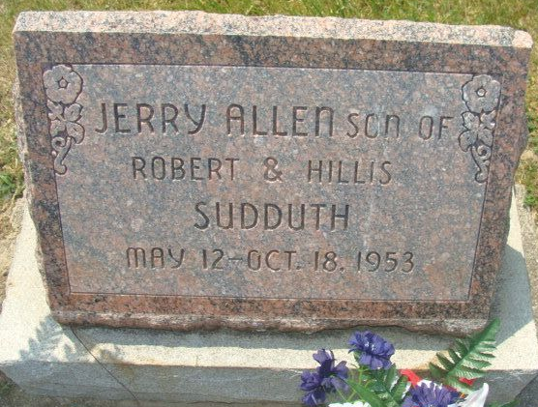
Photo by Alicia Kneuss

Jerry Suddeth
in the Indiana, U.S., Death Certificates, 1899-2017

Name Jerry Suddeth
Gender Male
Race White
Marital Status Single
Age 5/12
Birth Date 12 May 1953
Birth Place Decatur, Indiana
Death Date 18 Oct 1953
Death Place Fort Wayne, Allen, Indiana, USA
Death Registration Date 1953
Father Robert Suddeth
Mother Hillis A Williams
Informant Robert Suddeth; Decatur, Indiana
Burial October 20, 1953; Decatur Cemetery; Decatur, Indiana

