Herbert Sudduth
1936 - 1936

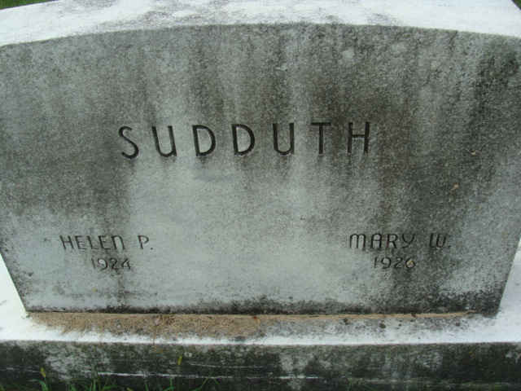
Photo by Alicia Kneuss

CARD OF THANKS

We wish in this manner to thank Rev. Franklin, the singers, and others for their kind assistance and floral offerings, during our recent bereavement.
Mr and Mrs. Harvey Sudduth.

Decatur Daily Democrat, Adams County, Indiana
February 26, 1936

**
Herbert Sudduth from tree Brodin Family Tree

Birth 1936 Decatur, Adams, Indiana, USA
Death 1936 Decatur, Adams, Indiana, USA
Father Harvey Maywood Sudduth (1909-1993)
Mother Marcella Charlotte Gilbert (1916-2000)

