Helen Pauline Sudduth
March 13, 1924 – April 30, 1924

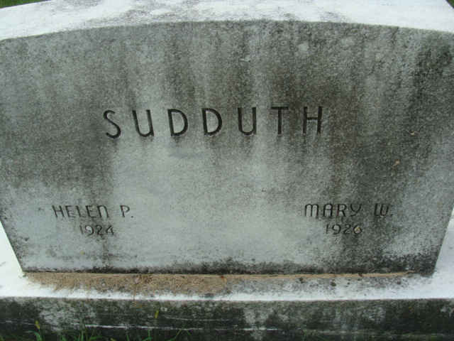
Photo by Alicia Kneuss

Helen Pauline Sudduth
in the Indiana, U.S., Birth Certificates, 1907-1944

Name Helen Pauline Sudduth; born alive
Gender Female
Birth Date 13 Mar 1924; 4:30 a.m.
Birth Place Decatur, Adams, Indiana, USA
Father Walter Sudduth; age 36
Mother Agnes Odle; age 35; 3rd child, all living
Certificate Number 11856
Roll number 40474_357277
Volume Range 21 - 25
**

Indiana, U.S., Death Certificates, 1899-2017

Name Hellem Pauline Suddeth
Gender Female
Race White
Age 0
Birth Date 13 Mar 1924
Birth Place Indiana
Death Date 30 Apr 1924
Death Place Washington, Adams, Indiana, USA
Death Registration Date 1924
Father Walter Suddeth
Mother Agnes Odle
Informant Walter Sudduth
Burial May 2, 1924; Decatur, Indiana

