Frederick J. Sudduth
May 23, 1924 – July 19, 2007

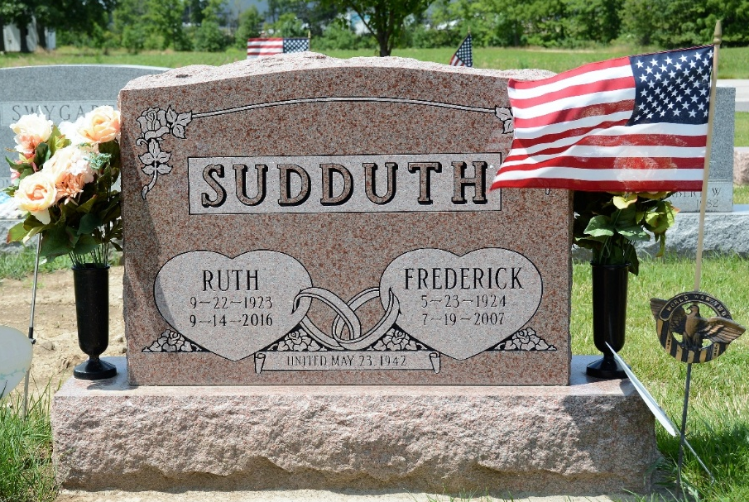
Photo by Deb Curry

Frederick J. Sudduth, 83 of Decatur passed away Thursday, July 19, 2007 at Adams Memorial Hospital. Fred was born May 23, 1924 in Adams County, Indiana to Ted & Lavaughn (Stetzel) Sudduth. His father is deceased. He married Ruth (Hamrick) on May 23, 1942.
Survivors are his mother Lavaughn Sudduth Johnson, wife Ruth Sudduth both of Decatur; 2 sons Gerald D. (Geraldine) Sudduth, Dennis J. (Tonya) Sudduth both of Decatur; 3 daughters Mrs. Ray (Carolyn L.) Roman, Mrs. John (Linda L.) Anderson, Mrs. Randall (Teresa A.) Sipe all of Decatur; 1 brother Robert L. Sudduth of Angola, step brother Ronald Johnson of Decatur; 1 sister Mrs. Richard (Joyce) Steiner of Linn Grove, IN; step sister Barbara Jarshaw of California; 20 grandchildren, 34 great grandchildren and 3 step grandchildren.
Preceding him in death was his father.
He was a member of the Solid Rock Community Church of the Nazarene in Decatur. Fred worked for Prestress services for 31 years and had a paper route for 13 years for the Decatur Daily Democrat.
He served his country in the United States Army during World War II.
Visitation is 11-4 pm Sunday, July 22, 2007 at Haggard & Sefton Funeral Home and 1 hour prior to services. Funeral services will be at 10:00 am Monday, July 23, 2007 at Haggard & Sefton Funeral Home with Military graveside rites by the American Legion Post 43. Rev. Tony Mosser will be officiating and burial is in Decatur Cemetery.
Memorials are to the Solid Rock Community Church of the Nazarene or Adams County Home Health.

Haggard Hirschy & Zelt Funeral Home, Adams County, Indiana
**

Frederick J. Sudduth, 83, a resident of Decatur, died on Thursday, July 19, 2007 at Adams Memorial Hospital. He was born on May 23, 1924, in Adams County, to Ted and Lavaughn (Stetzel) Sudduth. He was married on May 23, 1942 to Ruth Hamrick. She survives.
Visitation is from 11:00 a.m. to 4:00 p.m. on Sunday, July 22 at Haggard and Sefton Funeral Home and one hour prior to the 10:00 a.m. service on Monday, July 23 at the funeral home. Officiating is Rev. Tony Mosser. Burial will be in Decatur Cemetery with military graveside rites by American Legion Post #43.

Berne Tri-Weekly News, Berne, Adams County, Indiana
July 20, 2007

