Elias Kinsey Sudduth
August 26, 1869 – September 22, 1960

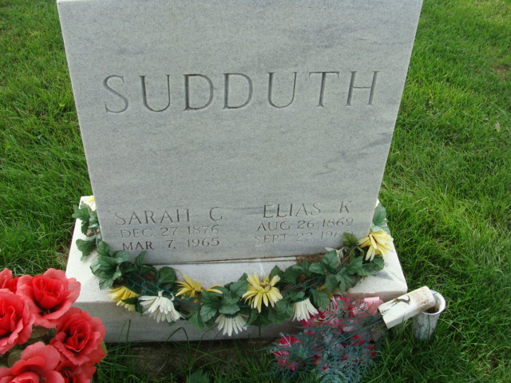
Photo by Alicia Kneuss

Elias K Sudduth
in the Indiana, U.S., Death Certificates, 1899-2017

Name Elias K Sudduth
Gender Male
Race White
Marital Status Married
Age 91
Birth Date 26 Aug 1869
Birth Place Ohio
Death Date 22 Sep 1960
Death Place Decatur, Adams, Indiana, USA
Death Registration Date 1960
Father Harrison Sudduth
Mother Hannah Nichols
Informant Mrs. Elias Sudduth; wife; Decatur, Indiana
Burial September 26, 1960; Maplewood Cemetery; Decatur, Indiana

