Earl E. Sudduth
August 3, 1900 – August 1, 1955

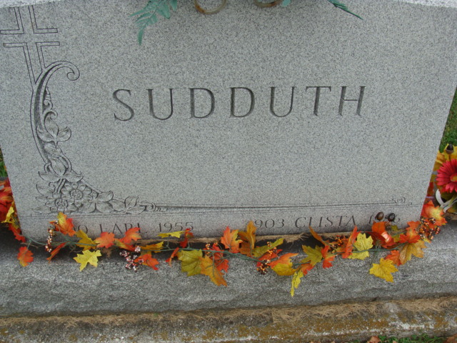
Photo by Alicia Kneuss

Earl E Sudduth
in the Indiana, U.S., Death Certificates, 1899-2017

Name Earl E Sudduth
Gender Male
Race White
Marital Status Married
Age 54
Birth Date 3 Aug 1900
Birth Place Decatur, Indiana
Death Date 1 Aug 1955
Death Place Decatur, Adams, Indiana, USA
Death Registration Date 1955
Father Elias Sudduth
Mother Sarah Gilbart
Informant Mrs. Clista Sudduth; Decatur, Indiana
Burial August 4, 1955; Decatur Cemetery; Decatur, Indiana

