Dorthy A. (Krick) Sudduth
March 15, 1912 – September 30, 1968

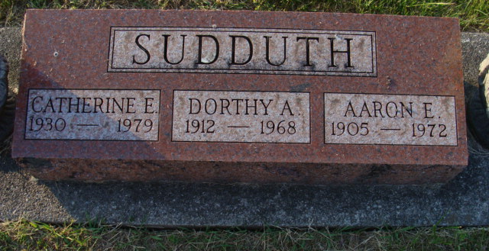
Photo by Alicia Kneuss

Dorothy Sudduth Dies at Hospital
Mrs. Dorothy A. Sudduth, 56, wife of Aaron Sudduth of 716 Schirmeyer street, and a lifelong resident of Decatur , died at 12:30 p.m. Monday at the Adams county memorial hospital following an extended illness.
Born in this city March 15, 1912?, she was a daughter of Winfred G. and Melinda Gause-Krick, and was married to Aaron Sudduth Sept. 14, 1929. Mrs. Sudduth attended the Church of the Nazarene.
Surviving are the husband; one daughter, Miss Catherine Sudduth of Decatur; two sons, Frank and Donald Sudduth, both of Fort Wayne; two sisters, Mrs. George (Helen) Hawkins and Mrs. Charles (Eileen) Garwood, both of Decatur; four brothers, Hubert, Doyle, Roger and Larry Krick, all of Decatur; and five grandchildren. One brother is deceased.
Funeral rites will be conducted at 2 p.m. Wednesday at the Winteregg-Linn funeral home, with Rev. Wilmer Watson officiating. Burial will be in the Decatur cemetery. Friends may call at the funeral home after 4 p.m. today until time of the services.

Decatur Daily Democrat, Adams County, Indiana
Tuesday, October 1, 1968

