Clista (Yoder) Sudduth
November 28, 1903 – May 20, 1986

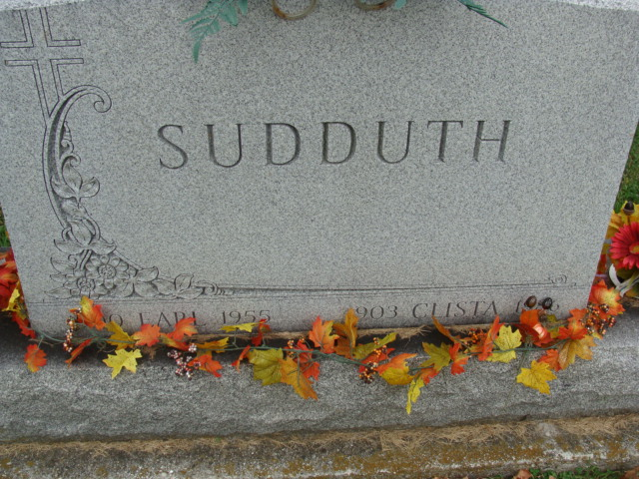
Photo by Alicia Kneuss

Clista Sudduth
in the Indiana, U.S., Death Certificates, 1899-2017

Name Clista Sudduth
[Clista Yoder]
Gender Female
Race White
Marital Status Widowed
Age 82
Birth Date 28 Nov 1903
Birth Place Indiana
Death Date 20 May 1986
Death Place Decatur, Adams, Indiana, USA
Death Registration Date 1986
Father Noah Yoder
Mother Rosanna Moeschberger
Informant Shirley Hakes; daughter; New Whiteland, Indiana
Burial May 29, 1986; Decatur Cemetery; Decatur, Indiana

