Catherine E. Sudduth
January 22, 1930 – September 8, 1979

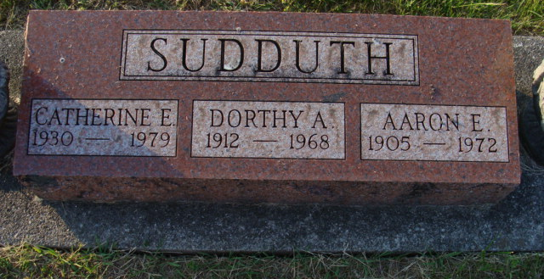
Photo by Alicia Kneuss

Catherine Sudduth, 49, 716 Schirmeyer St., died at 11 p.m. Saturday at the Crow Nursing Home in Fort Wayne; death followed an extended illness.
An employee of the Bag Service here for over 30 years, she was born January 22, 1930 in Decatur to Aaron and Dorothy A. Krick-Sudduth.
Survivors include two brothers, Don and Frank Sudduth, both of whom reside in Fort Wayne, and several nieces and nephews.
Graveside rites will be held at 10:30 a.m. Tuesday at the Decatur Cemetery, Rev. Donald Ault in charge. Friends may call at the Winteregg-Linn & Haggard Funeral Home after 6 tonight.

Decatur Daily Democrat, Adams County, Indiana
Monday, March 20, 1972

