Argo Bryson Sudduth
March 25, 1912 – February 12, 1993

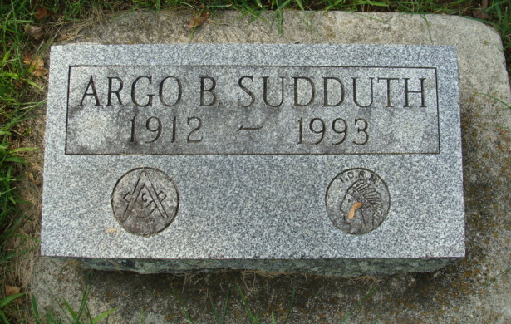
Photo by Alicia Kneuss

Bryson A Suddeth
in the Indiana, U.S., Birth Certificates, 1907-1944

Name Bryson A Sudduth; born alive
Gender Male
Birth Date 25 Mar 1912
Birth Place Decatur, Adams, Indiana, USA
Father Walter Sudduth; age 25
Mother Agnes Odle; age 24; 1st child
Certificate Number 112
Roll number 40474_358006
Volume Range 480 - 486
**

Indiana, U.S., Death Certificates, 1899-2017

Name Argo B Sudduth
Gender Male
Race White
Marital Status Divorced
Age 80
Birth Date 24 Mar 1912
Birth Place Adams County, Indiana
Death Date 12 Feb 1993
Death Place Decatur, Adams, Indiana, USA
Death Registration Date 1993
Father Walter Sudduth
Mother Agnes Odle
Informant Betty Beard; sister; Decatur, Indiana
Burial February 15, 1993; Decatur Cemetery; Decatur, Indiana

