Alva Franklin D. Suddeth
April 24, 1904 – September 19, 1943

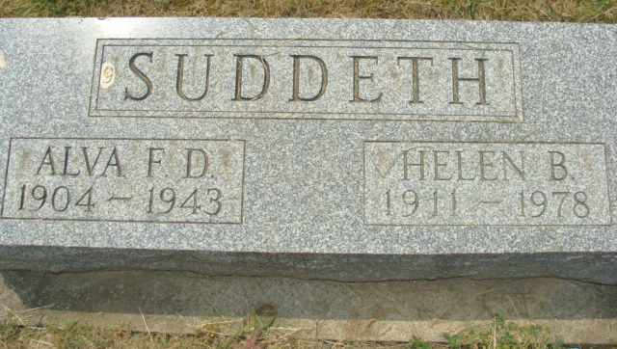
Photo by Alicia Kneuss

SUDDUTH

DECATUR, Sept. 21 - Funeral services were held this afternoon for Alva Franklin Sudduth, 39, who died Sunday at the Adams County Memorial Hospital after a short illness. Surviving are the widow, the mother and eight children, all of Decatur. One child was born Monday morning at the hospital here - about 24 hours after her father's death. Burial was in Decatur cemetery.

Decatur Daily Democrat, Adams County, Indiana
Tuesday, 20 Sep 1943
**

Indiana, U.S., Death Certificates, 1899-2017

Name Alva F Sudduth
Gender Male
Race White
Marital Status Married
Age 39
Birth Date 24 Apr 1904
Birth Place Decatur, Indiana
Death Date 19 Sep 1943
Death Place Decatur, Adams, Indiana, USA
Death Registration Date 1943
Father Albert Sudduth
Mother Mary Logan
Spouse Helen Sudduth; age 33
Informant Mrs. Helen Sudduth; Decatur, Indiana
Burial September 21, 1943; Decatur Cemetery; Decatur, Indiana

