Agnes Ada (Odle) Sudduth
March 19, 1888 – March 10, 1959

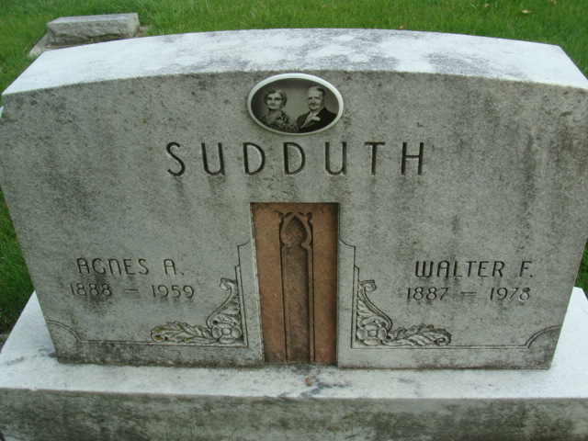
Photo by Alicia Kneuss

Agnes Ada Sudduth
in the Indiana, U.S., Death Certificates, 1899-2017

Name Agnes Ada Sudduth
[Agnes Ada Odle]
Gender Female
Race White
Marital Status Married
Age 70
Birth Date 19 Mar 1888
Birth Place Indiana
Death Date 10 Mar 1959
Death Place Decatur, Adams, Indiana, USA
Death Registration Date 1959
Father Aaron Odle
Mother Celia Smith
Informant Walter F. Sudduth; husband; Decatur, Indiana
Burial March 13, 1959; Decatur Cemetery; Decatur, Indiana

