Aaron Edgar Sudduth
December 2, 1905 – March 19, 1972

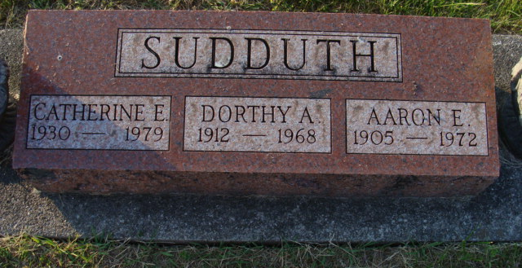
Photo by Alicia Kneuss

Aaron E. Sudduth Dies at Hospital
Aaron E. Sudduth, 66, of 716 Schirmeyer street, died at 8:40 a.m. Sunday at the Adams county memorial hospital, where he had been a patient four days.
He was born in Decatur Dec. 2, 1905, a son of Elias and Sarah Gilbert-Sudduth, and was married to Dorothy A. Krick Sept. 14, 1929. His wife preceded him in death Sept. 30, 1968.
Mr. Sudduth was a member of the Church of the Nazarene and was a retired maintenance man at the Parrott Packing Co. in Fort Wayne .
Surviving are a daughter, Miss Catherine Sudduth of Decatur; two sons, Frank and Donald Sudduth, both of Fort Wayne; a sister, Mrs. Jesse (Jeanette) Plasterer of Decatur, and five grandchildren. Three brothers are deceased.
Funeral services will be conducted at 1:30 p.m. Tuesday at the Winteregg-Linn funeral home, with Rev. Cloyce C. Cunningham officiating. Burial will be in the Decatur cemetery. Friends may call at the funeral home after 2 p.m. today until time of the services.

Decatur Daily Democrat, Adams County, Indiana
Monday, March 20, 1972

