Helen B. (Hess) Suddeth-Hendricks
May 19, 1911 – November 2, 1978

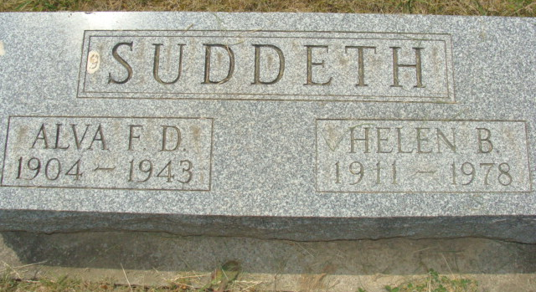
Photo by Alicia Kneuss

Decatur Public Library (Adams Co, IN) online obit abstracts

Title: Hendricks, Helen B.
Publication: Decatur Daily Democrat; Date: 03 NOV 1978
Subjects: Obituaries -- H -- 1970-1979
Abstract: Age 67; Born: May 19,1911 in Decatur , IN ; Died: Thursday, November 2,1978; Married: 1st: Alva Sudduth, who died September 19,1943; 2nd: John J. Hendricks, who died October 25,1971
**

Indiana, U.S., Death Certificates, 1899-2017

Name Helen B Hendricks
[Helen B Hess]
Gender Female
Race White
Marital Status Widowed
Age 67
Birth Date 19 May 1911
Birth Place Indiana
Death Date 2 Nov 1978
Death Place Decatur, Adams, Indiana, USA
Death Registration Date 1978
Father Jacob Hess
Mother Amanda Schroll
Informant Mrs. Terry Jones; Decatur, Indiana
Burial November 6, 1978; Decatur Cemetery; Decatur, Indiana

