Martha (Boese) Sudbrink
February 4, 1885 – October 18, 1962

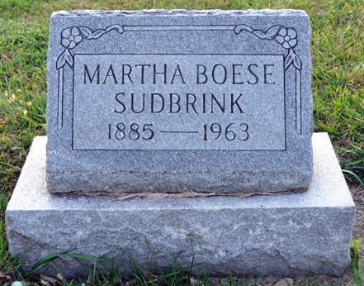
Photo by Deb Curry

Martha Sudbrink
in the Ohio, U.S., Death Records, 1908-1932, 1938-2022

Name Martha Sudbrink
Gender Female
Race White
Marital Status Divorced
Death Age 78
Birth Date Abt 1885
Residence Place Auglaize, Ohio, USA
Death Date 18 Oct 1963
Death Place Auglaize, Ohio, USA
Certificate Number 73008
Inquest Hospital Home
Inquest Questions Certifier: Physician; Autopsy Performed?: Yes, Used For Certification;
**

U.S., Social Security Death Index, 1935-2014

Name Martha Sudbrink
Social Security Number xxx
Birth Date 4 Feb 1885
Issue year 1951
Issue State Pennsylvania
Death Date Oct 1963
**

New York State, Marriage Index, 1881-1967

Name Martha Boese
Gender Female
Marriage Date 4 Feb 1915
Marriage Place Buffalo, New York, USA
Spouse Charles Sudbrink
Certificate Number 1529
**

Martha C Boese from tree Weiler Family Tree

Birth 4 Feb 1885 Indiana, USA
Marriage 4 Feb 1915 Buffalo, Erie, New York, USA
Residence 1943 Erie, Erie, Pennsylvania, USA
Death 18 Oct 1963 Auglaize, Allen, Ohio, USA
Father *Ernst Friedrich Wilhelm "William" Boese (1838-1920)
Mother Elise W. E. Blomenburg (1845-1890)
Spouse Charles William Sudbrink (1887-1957)

