Sadie (Keller) Stump
February 28, 1887 – January 7, 1970

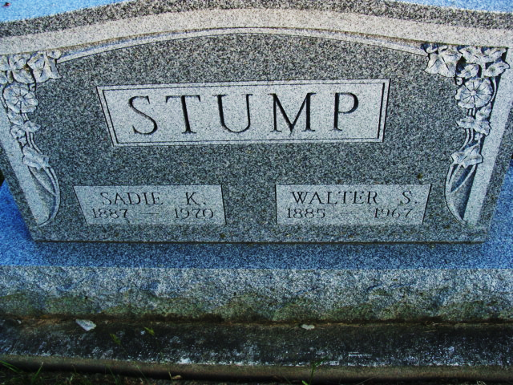
Photo by Alicia Kneuss

Mrs. Sadie Stump dies last night

Mrs. Sadie K. Stump, 82, of Preble, died at 11:55 p.m. Wednesday at the Adams County Memorial Hospital following an extended illness.
She was born in Ohio Feb. 28, 1887, and was married to Walter S. Stump Aug. 10, 1912. Her husband preceded her in death July 25, 1967.
Mrs. Stump was a member of the Washington St. Church of Christ in this city.
Surviving is one daughter, Mrs. Robert (Alberta) Gerber of Preble, with whom Mrs. Stump made her home; two sons, Charles R. Stump of Urbana, O., and Carroll Stump of Troy, O.; one sister, Mrs. Clarence (Dehlie) Curry of Villa Grove, Ill.; and four grandchildren. One daughter, Mrs. Josephine Voglewede, preceded her in death.
Funeral services will be conducted at 2 p.m. Saturday at the Winteregg-Linn Funeral Home, with Robert L. Bernhardt officiating. Burial will be in the Decatur Cemetery. Friends may call at the funeral home after 2 p.m. Friday until time of the services.

Decatur Daily Democrat, Adams County, Indiana
Thurs. Jan. 8, 1970
**

Indiana, U.S., Death Certificates, 1899-2017

Name Sadie K Stump
Gender Female
Race White
Marital Status Widowed
Age 82
Birth Date 28 Feb 1887
Birth Place Ohio
Death Date 7 Jan 1970
Death Place Decatur, Adams, Indiana, USA
Death Registration Date 1970
Parents Unknown
Informant Mrs. Robert Gerber; daughter; Preble, Indiana
Burial January 10, 1970; Decatur Cemetery; Decatur, Indiana

