Lewis Stump
November 20, 1890 – January 5, 1971

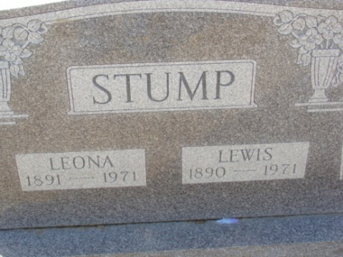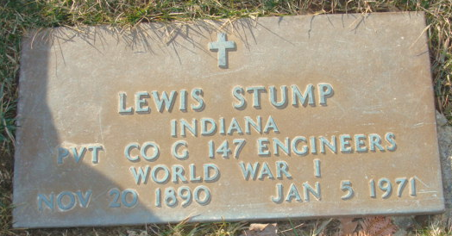
Photo by Alicia Kneuss

Lewis Stump Dies after Long Illness
Lewis Stump, 80, retired farmer of Decatur route 6, died at 11:35 p.m. Tuesday at the Adams County Memorial Hospital following an extended illness. He was born in Monroe Nov. 20, 1890, a son of James and Rebecca E. Haggard-Stump, and was married to Leona Walker Nov. 13, 1907.
Mr. Stump, a veteran of World War 1, was a member of the American Legion and the Brotherhood of Railroads.
Surviving are his wife; one son, Russell L. Stump of Decatur route 6; two daughters, Mrs. Paul L. (Maxine) Myers of Decatur, and Mrs. Warren (Phyllis) Nidlinger of Decatur route 3; two stepsons, Carl R. Noack of Shepherd, Mich., and Norman L. Noack of Fort Wayne; one sister, Mrs. Meda Marshand of Decatur route 6; two half-sisters, Mrs. Clarence (Frances) Martin and Mrs. Homer (Cecil) Martin, both of St. Petersburg, Fla.,; a half-brother, George Stump of St. Petersburg, Fla.; ten grandchildren and four great-grandchildren. Two sisters, one brother, and one great-grandchild preceded him in death.
Funeral services will be conducted at 2 p.m. Friday at the Winteregg-Linn Funeral Home, with Rev. Lawrence T. Norris officiating. Burial will be in the Decatur Cemetery. Friends may call at the funeral home from 2 p.m. Thursday until 1 p.m. Friday, when the casket will be closed.

Decatur Daily Democrat, Adams County, Indiana
Wednesday, January 6, 1971

