Leona (Walker) Stump
June 9, 1891 – January 25, 1971

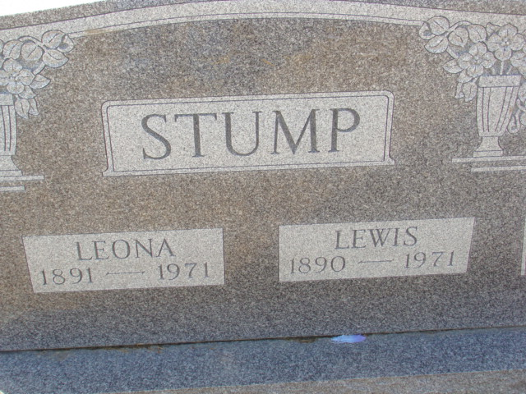
Photo by Alicia Kneuss

BULLETIN

Mrs. Lewis Stump, 79, of Decatur route 6, died at 1 p.m. today at the Adams county memorial hospital. Her husband died Jan. 5 of this year. The body was removed to the Winteregg-Linn funeral home. Funeral arrangements have not been completed. (no date)

Berne Public Library Heritage Room
More Misc Obits

**
Mrs. Leona Stump dies at hospital

Mrs. Leona Stump, 79, of Decatur route 6, died at 12:45 p.m. Monday at the Adams county memorial hospital following an extended illness.
She was born in Wayne county June 9, 1891, to John and Mary Puthoff-Walker, and was married to Lewis Stump Nov. 13, 1917. Her husband preceded her in death Jan. 5 of this year.
Surviving are three sons, Carl R. Noack of Shepherd, Mich., Norman L. Noack of Fort Wayne, and Russell L. Stump of Decatur route 6; two daughters, Mrs. Paul L. (Maxine) Myers of Decatur and Mrs. Warren (Phyllis) Nidlinger of Decatur route 3; two sisters, Mrs. Tilla Hurst of Decatur, and Mr. John (Irene) Puthoff of New Paris, O.; one brother, Jack Walker of Breckenridge, O.; 11 grandchildren and 10 great-grandchildren. Four sisters and one great-grandchild are deceased.
Funeral services will be conducted at 2 p.m. Thursday at the Winteregg-Linn funeral home with Rev. Lawrence T. Norris officiating. Burial will be in the Decatur cemetery. Friends may call at the funeral home from 2 p.m. Wednesday until 1 p.m. Thursday, when the casket will be closed.

Unknown source
Dated Monday, January 25, 1971
**

Indiana, U.S., Death Certificates, 1899-2017

Name Leona Stump
[Leona Walker]
Gender Female
Race White
Marital Status Widowed
Age 79
Birth Date 9 Jun 1891
Birth Place Indiana
Death Date 25 Jan 1971
Death Place Decatur, Adams, Indiana, USA
Father John Walker
Mother Mary Puthoff
Informant Russell L. Stump; son; Decatur, Indiana
Burial January 28, 1971; Decatur Cemetery; Decatur, Indiana

