Thrueman W. Stults
February 9, 1917 – February 17, 1997

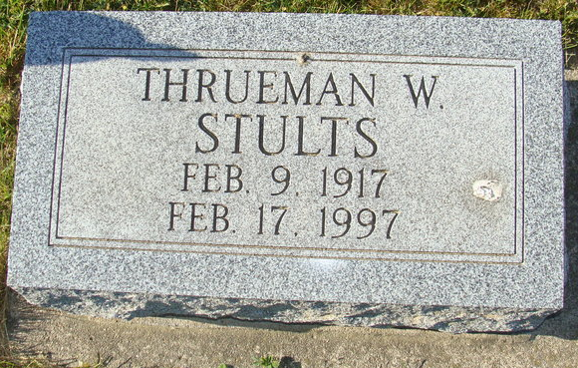
Photo by Alicia Kneuss

THRUEMAN W. STULTS, 80, of Taylor, Mich., died Monday. The Decatur native retired from Ford Motor Co. after 30 years and was a veteran of World War II. Surviving are his wife, Anita L.; a daughter, Karen S. Stults of Taylor; a son, Ronald W. of Taylor; a brother, Thearl of Decatur; five grandchildren; and six great-grandchildren. Services were private in Decatur Cemetery. Arrangements were by Zwick-Sefton & Jahn Funeral Home, Decatur. Memorials are to the Adams County Diabetes Association or Heart Club.

News-Sentinel, The (Allen County, Indiana)
Tuesday, February 18, 1997
**

U.S., Social Security Applications and Claims Index, 1936-2007

Name Thrueman Wayne Stults
Gender Male
Race White
Birth Date 9 Feb 1917
Birth Place Decatur Adam, Indiana
Death Date 17 Feb 1997
Father Francis M Stults
Mother May Miller
SSN xxx
Notes May 1937: Name Listed As Thrueman Wayne Stults; 27 Feb 1997: Name Listed As Thrueman W Stults
**

Indiana, U.S., Marriages, 1810-2001

Name Thrueman Wayne Stults
Gender Male
Race White
Age 29
Event Type Marriage Registration (Marriage)
Birth Date 2 Sep 1917
Birth Place Decatur, Adams, Indiana
Marriage Date 18 Jan 1946
Marriage Place Fort Wayne, Indiana, United States
Residence Place Detroit, Michigan
Father Marion Francis Stults
Mother May Olive Miller
Spouse Anita Lucile Stoddard
Page 171

