Thearl E. M. Stults
March 13, 1914 – November 22, 2000

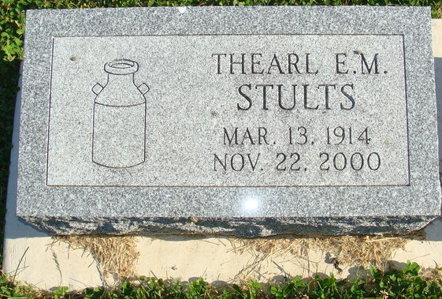
Photo by Alicia Kneuss

Thearl E. M. Stults
in the Indiana, U.S., Death Certificates, 1899-2017

Name Thearl E. M. Stults
Gender Male
Race White
Marital Status Married
Age 86
Birth Date 13 Mar 1914
Birth Place Adams County
Death Date 22 Nov 2000
Death Place New Haven, Allen, Indiana, USA
Death Registration Date 2000
Father Francis Marion Stults
Mother Olive May Miller
Spouse Mina Schug
Informant Mina Ellen Stults; wife; Decatur, Indiana
Burial November 25, 2000; Decatur Cemetery; Decatur, Indiana

