Rick Lynn Stults
December 26, 1965 – June 30, 1990

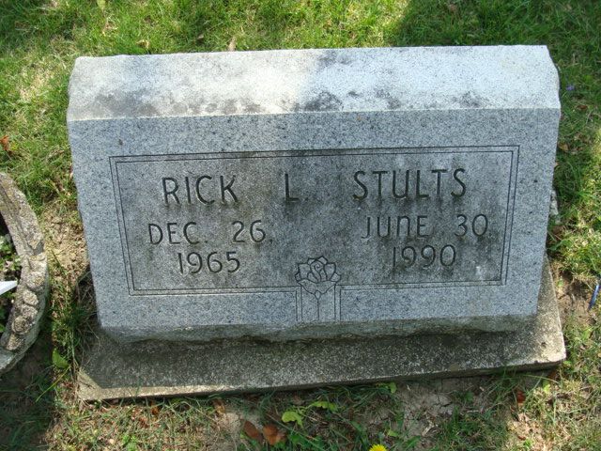
Photo by Alicia Kneuss

Rick L. Stults, 24; Accident Victim

DECATUR, Ind. – Services for Rick L. Stults, 24, will be at 10 a.m. Tuesday in Zwick-Sefton and Jahn Funeral Home, with Rev. Wendle Brane officiating. Burial will be in Decatur Cemetery.
- Accident article on Page 12 A
Calling will be 2-5 and 7-9 p.m. Monday at the funeral home.
Mr. Stults died Saturday in a single car accident. He was employed at Fleetwood Motor Homes in Decatur.
Survivors include his wife, Jennifer; a daughter, Tyra; a stepson, Derrick Costello; his parents Earl and Jama, Bryant; paternal grandmother, Kathaleen Stults, Portland; maternal grandmother, Helen Louis, Muncie, and four brothers, Chris Stults, Glennburie, Md., Shannon Stults, Pendleton, and Nick and Bill Stults, both of Bryant.

The Muncie Star, Delaware County, Indiana
Sunday, July 1, 1990, p. C10
**

Rick L. Stults, 24, died Saturday of injuries sustained in an auto accident near Decatur. He worked at Fleetwood Motor Homes, Inc. Surviving are his wife, Jennifer; a daughter; a stepson; parents, Jama and Earl Stults of Bryant; four brothers and grandmothers, Kathaleen Stults of Portland and Helen Lewis of Muncie. Services are 10 am tomorrow in Zwick-Sefton & Jahn Funeral Home, where calling is 2 to 5 and 7 to 9 pm today. Burial will be in Decatur Cemetery.

Journal-Gazette, Allen County, Indiana
July 2, 1990, p. 4A
**

Indiana, U.S., Death Certificates, 1899-2017

Name Ricky L Stults
Gender Male
Race White
Marital Status Married
Age 24
Birth Date 26 Dec 1965
Birth Place Jay County, Indiana
Death Date 30 Jun 1990
Death Place Decatur, Adams, Indiana, USA
Father Earl W Stults
Mother Jama S Rohlfing
Spouse Jennifer McDonald
Informant Mrs. Jennifer Stults; wife; Decatur, Indiana
Burial July 3, 1990; Decatur Cemetery; Decatur, Indiana

