Orrin Stults
December 29, 1902 – November 10, 1981

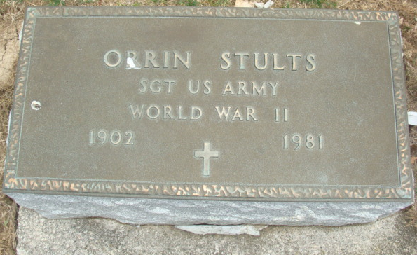
Photo by Alicia Kneuss

Orrin Stults
in the Ohio, U.S., Death Records, 1908-1932, 1938-2022

Name Orrin Stults
Gender Male
Race White
Marital Status Not married (Married)
Death Age 78
Birth Date Abt 1903; Birth Place Ohio, USA
Death Date 10 Nov 1981; Death Place Van Wert, Ohio, USA
Certificate Number 085623
Inquest Hospital Long-Term Care Facilities
Inquest Questions Certifier: Physician; Autopsy Performed?: Yes, Used For Certification;
**

U.S., Department of Veterans Affairs BIRLS Death File, 1850-2020

Name Orrin Stults
Birth Date 29 Dec 1902
Death Date 10 Nov 1981
SSN xxx
Enlistment Branch Army
Enlistment Date 10 Aug 1942; Discharge Date 30 Jul 1945
Page number 4
**

Orrin Stults from tree Out on a limb - our family tree

Birth 29 Dec 1902 Ohio, USA
Residence 1930 Adams, Indiana, USA
Death 10 Nov 1981 Long-Term Care Facilities
Father Wesley H Stults (1858-1940)
Mother Elizabeth Heiptley (Born 1868)

