Olive May (Miller) Stults
March 18, 1886 – March 9, 1965

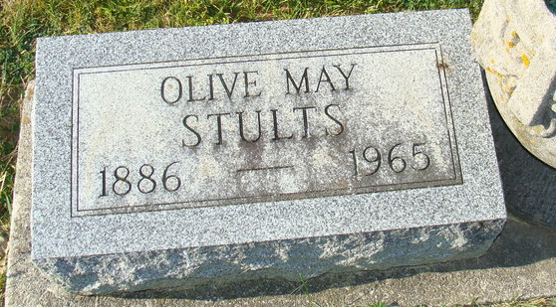
Photo by Alicia Kneuss

Ollive May Stucks
in the Indiana, U.S., Death Certificates, 1899-2017

Name Ollive May Stults
[Ollive May Miller]
Gender Female
Race Caucasian (White)
Marital Status Married
Age 78
Birth Date 18 Mar 1886
Birth Place Ohio
Death Date 9 Mar 1965
Death Place Decatur, Adams, Indiana, USA
Death Registration Date 1965
Father William J Miller
Mother Ella Hacket
Informant Marion Stults; husband; Decatur, Indiana
Burial March 11, 1965; Decatur Cemetery; Decatur, Indiana

