Mina Ellen (Schug) Stults
February 24, 1919 – November 11, 2009

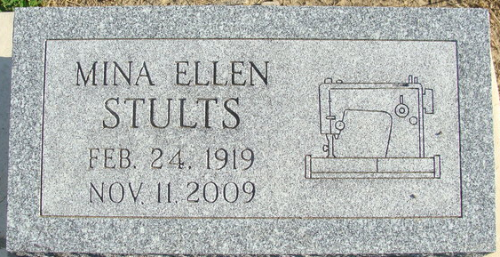
Photos by Deb Curry

Ellen Stults, 90 years old of Fort Wayne, Indiana and a former longtime resident of Decatur, passed away on Wednesday, November 11, 2009 in the Parkview North Hospital. She was born on Monday, February 24, 1919 in Berne, Indiana, the daughter of the late Homer E. Schug and the late Gail (Sullivan) Schug. She married Thearl Stults on May 8, 1936 in Huntington, Indiana and he passed away on November 22, 2000.
Ellen was a member of the Union Chapel United Methodist Church where she was involved in the Ladies Circle of the church. She was also active in the Live and Learn Home Economics Club. She worked for Brooks Menswear from 1960 to 1976.
Surviving is her daughter, Beverly (Stephen) Litchfield of Fort Wayne, son, Terry S. (Cindy) Stults of Fort Wayne, six grandchildren, nine great-grandchildren, and one great, greatgrandchild.
Funeral services will be held at 12:30 p.m. Saturday, November 14, 2009 in the Zwick & Jahn Funeral Home with Pastor Ed Karges officiating. Interment will follow in the Decatur Cemetery. Friends will be received from 10:30 a.m. until the time of the funeral service Saturday in the funeral home.
Preferred memorials are to the Union Chapel United Methodist Church.

Zwick & Jahn Funeral Home, Adams County, Indiana
November 12, 2009

