Mary Ester (Aurand) Stults
April 18, 1901 – December 29, 1982

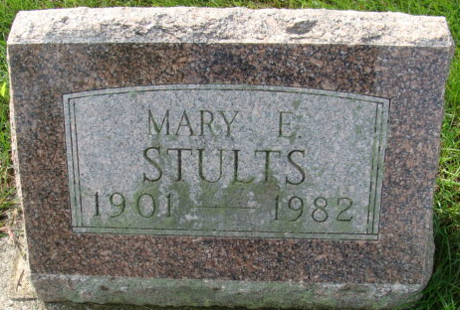
Photo by Alicia Kneuss

Thursday's listing in the Democrat of the time of the funeral for Mary E. Stults was incorrect. It will be at 2 p.m. - not 3 p.m. - on Sunday, January 2, at the Zwick, Boltz, and John Funeral Home.
Decatur Daily Democrat, Adams County, Indiana
Friday, December 31, 1982

**
Mary A Stults
in the Georgia, Death Index, 1919-1998
Name: Mary A Stults
Gender: Female
Race: White
Age: 81
Birth Date: abt 1901
Residence Place: Appling, Georgia, USA
Death Date: 29 Dec 1982
Death Place: Houston, Georgia, USA
File Date: 30 Dec 1982
Certificate Number: 042443
**
Mary Stults
in the U.S., Social Security Death Index, 1935-2014
Name: Mary Stults
Social Security Number: xxx
Birth Date: 18 Apr 1901
Issue Year: Before 1951
Issue State: Indiana
Last Residence: 46733, Decatur, Adams, Indiana, USA
Death Date: Dec 1982

