John B. Stults
July 3, 1896 – February 1, 1969

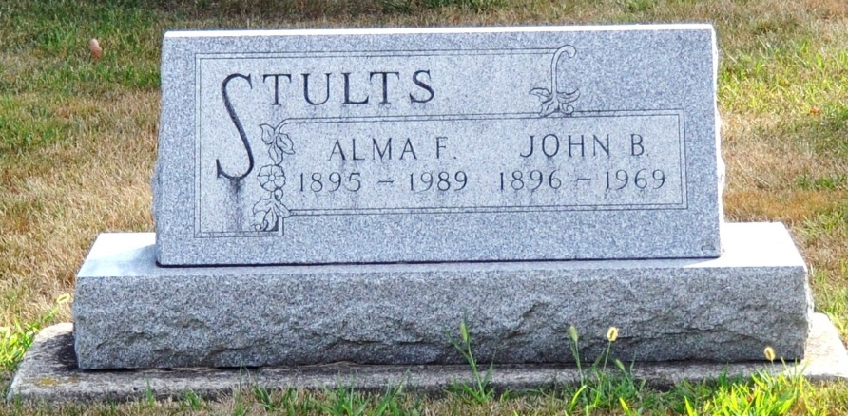
Photo by Deb Curry

John B. Stults, former mayor, dies at hospital

John B. Stults, 72, of 305 West Adams Street, prominent Decatur resident, former mayor of Decatur and a former city court judge, died at 6 o'clock this morning at the Adams County Memorial Hospital. Mr. Stults had been hospitalized since suffering a heart attack a week ago, but his death this morning was unexpected.
The former mayor purchased the Mills Grocery from Fred V. Mills in downtown Decatur Nov. 1, 1927, and operated the grocery until retiring Jan. 5, 1950.
Active for years in Democratic party circles, Mr. Stults served as mayor of Decatur from 1943 to 1947. He was appointed as Decatur City Judge in 1961, and served until retiring Jan. 1, 1968. Mr. Stults was a member of the board of trustees of the Adams County Memorial Hospital from 1937 until 1942, and was also a member of the board of trustees of the Decatur Cemetery Association.
A lifelong resident of Adams County, he was born July 3, 1896, a son of Alva L. and Carrie Shrank-Stultz, and was married to Miss Alma Brown June 24, 1925.
Mr. Stults was a member of the First United Methodist Church and the Knights of Pythias Lodge.
Surviving are his wife and one brother, George W. Stults of Decatur. One sister and one brother are deceased.
Funeral services will be conducted at 2 p.m. Monday at the Winteregg-Linn Funeral Home, with Rev. Melvin Seeger officiating. Burial will be in the Decatur Cemetery. Friends may call at the funeral home from 7 p.m. Saturday until 12 noon Monday. The casket will be closed prior to the services. Preferred memorials are to the building fund of the First United Methodist Church.

Decatur Daily Democrat, Adams County, Indiana
Saturday, Feb. 1, 1969

