James Douglas Stults
February 10, 1862 – February 25, 1954

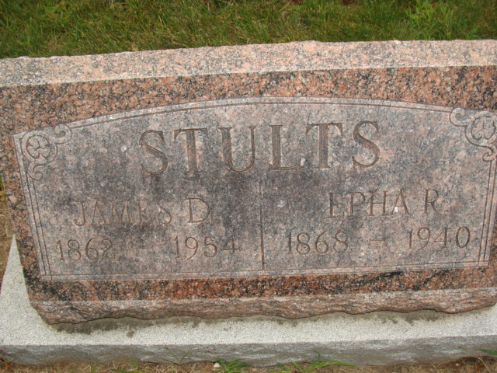
Photo by Alicia Kneuss

JAMES D. STULTS

CHARLOTTE - James D. Stults, 92, died of a heart ailment Thursday afternoon at the home of his daughter, Mrs. Harrison Waldon, at 903 E. Shepherd St., where he had resided for the past twelve years. He was born February 10, 1862, in Decatur, Ind., the son of Jacob and Lucinda Stults and resided in Decatur all of his life until he came here twelve years ago. Surviving are: three daughters, Mrs. Zelly Glancy of Winchester, Ind., Mrs. Naomi Whittgerfeld of Fort Wayne, Ind. and Mrs. Waldon, and two sons, J. T. Stults of Shelby, Ohio and Charles Stults of Oxnard, Calif.

Battle Creek Enquirer; Battle Creek, Michigan
Saturday, Feb. 27, 1954
**

James D Stults from tree Ernsberger, Huffman and related families

Birth 10 Feb 1862 Decatur, Adams, Indiana, USA
Marriage 1 Oct 1884 Allen, Indiana, USA
Residence 13 Apr 1950 Charlotte, Eaton, Michigan, USA
Death 26 Feb 1954 Charlotte, Eaton, Michigan, USA
Father Jacob Stultz (1826-1893)
Mother Lucinda Sheneman (1834-1865)
Spouse Ephra Rachael "Effie" Kern (1868-1940)

