Harry L. Stults
February 17, 1900 – September 28, 1958

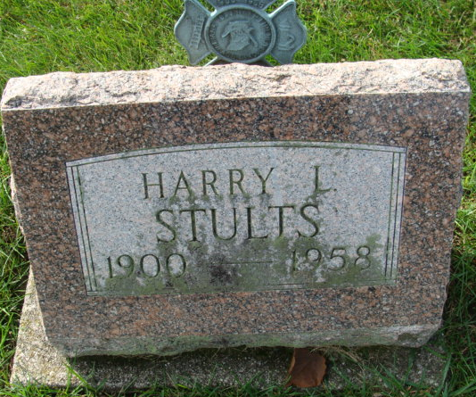
Photo by Alicia Kneuss

Harry L Stults
in the Indiana, U.S., Death Certificates, 1899-2017

Name Harry L Stults
Gender Male
Race White
Marital Status Married
Age 58
Birth Date 17 Feb 1900
Birth Place Van Wert Co. Ohio
Death Date 28 Sep 1958
Death Place Decatur, Adams, Indiana, USA
Death Registration Date 1958
Father Alva Lee Stults
Mother Carrie
Informant Mrs. Harry Stults; wife; Decatur, Indiana
Burial September 30, 1958; Decatur Cemetery; Decatur, Indiana

