Harry Daniel Stults
December 19, 1926 – December 19, 1926

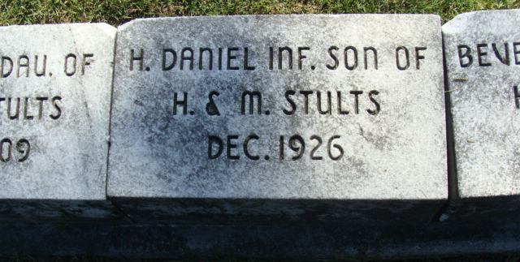
Photo by Alicia Kneuss

Harry Hanial Stults
in the Indiana, U.S., Death Certificates, 1899-2017

Name Harry Danial Stults
Gender Male
Race White
Marital Status Single
Age 3 hours
Birth Date 19 Dec 1926
Birth Place Indiana
Death Date 19 Dec 1926
Death Place Decatur, Adams, Indiana, USA
Death Registration Date 1926-1927
Father Harry Stults
Mother Maray E Auerand
Informant Harry Stults; Decatur, Indiana
Burial December 21, 1926; Decatur Cemetery

