Francis W. D. Stults
April 6, 1908 – October 4, 1983

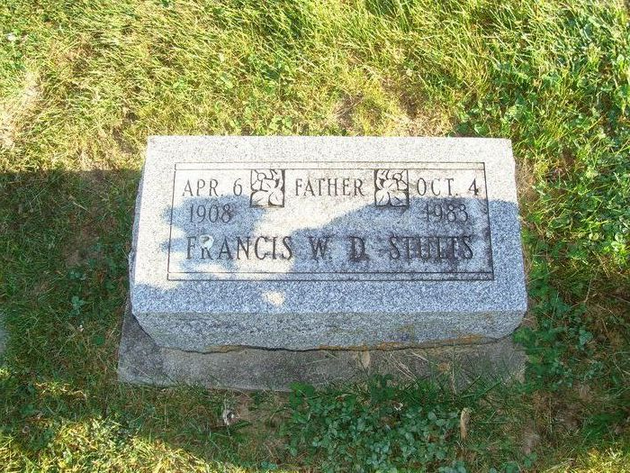
Photo by Alicia Kneuss

Francis W. Stults
in the Indiana, U.S., Death Certificates, 1899-2017

Name Francis W. Stults
Gender Male
Race White
Marital Status Married
Age 75
Birth Date 6 Apr 1908
Birth Place Indiana
Death Date 4 Oct 1983
Death Place Fort Wayne, Allen, Indiana, USA
Death Registration Date 1983
Father Francis M. Stults
Mother Olive May Miller
Spouse May
Informant May Stults; wife; Fort Wayne, Indiana
Burial October 6, 1983; Decatur Cemetery; Decatur, Indiana
Thearl Stults; son; Decatur, Indiana
Burial September 23, 1965; Decatur Cemetery; Decatur, Indiana

