Francis Marion Stults
September 10, 1877 – September 21, 1965

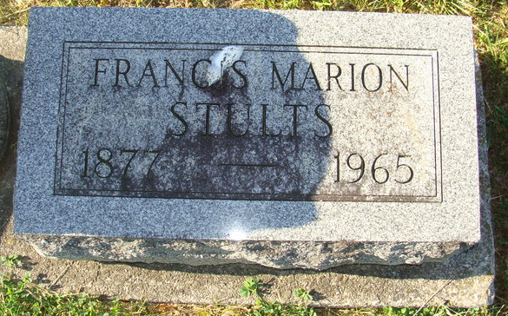
Photo by Alicia Kneuss

Marion Francis Stults
in the Indiana, U.S., Death Certificates, 1899-2017

Name Marion Francis Stults
Gender Male
Race Caucasian (White)
Marital Status Widowed
Age 88
Birth Date 10 Sep 1877
Birth Place Indiana
Death Date 21 Sep 1965
Death Place Bluffton, Wells, Indiana, USA
Death Registration Date 1965
Father John D Stults
Mother Josephine House
Informant Thearl Stults; son; Decatur, Indiana
Burial September 23, 1965; Decatur Cemetery; Decatur, Indiana

