Florence S. W. (Kuhn) Stults
November 26, 1903 – January 30, 1948

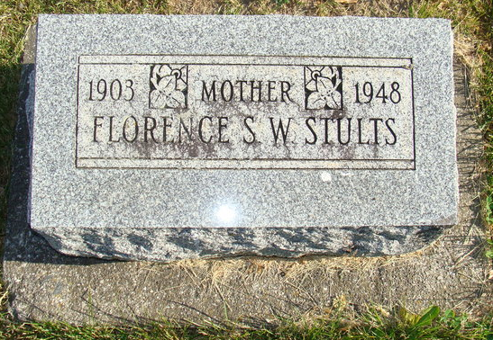
Photo by Alicia Kneuss

Florance C W Stults
in the Indiana, U.S., Death Certificates, 1899-2017

Name Florence S W Stults
[Florence S W Kuhn]
Gender Female
Race White
Marital Status Married
Age 44
Birth Date 26 Nov 1903
Birth Place Chattooga Ohio
Death Date 30 Jan 1948
Death Place Fort Wayne, Allen, Indiana, USA
Death Registration Date 1948
Father Philip Kuhn
Mother Fannie Sielschott
Spouse Francis Stults; age 39
Informant Francis Stults; Fort Wayne, Indiana
Burial February 2, 1948; Maplewood Cemetery; Decatur, Indiana

